AL-FARABI KAZAKH NATIONAL UNIVERSITY
Faculty of Law
Department of Customs, Financial and Environmental Law

FINAL EXAMINATION PROGRAM

APV 6306 Actual problems of water law

educational program of «7M042-Maritime and energy law

Almaty 2025

The final examination program of the course was developed by Senior Lecturer G.B. Teleuyev.
It was prepared on the basis of the educational program «7M042 – Maritime and Energy Law».

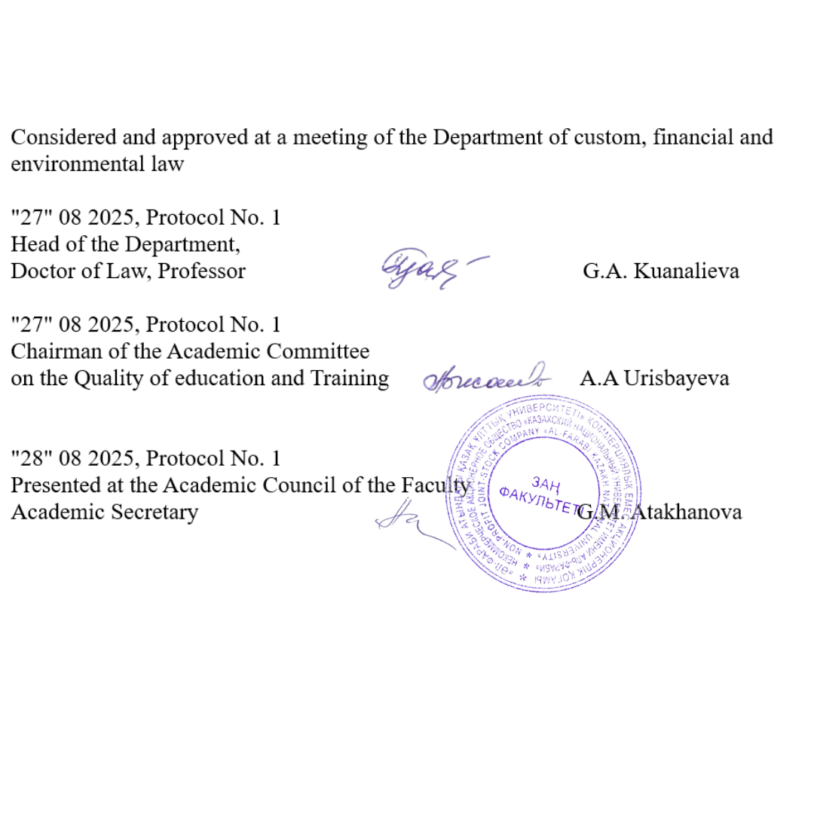

Introduction
Studying in the master's program is carried out in accordance with the State Standard of Compulsory Education of the Republic of Kazakhstan and academic policy, the study of the discipline ends with a final exam, which consists of passing the exam. Only undergraduates who have scored the appropriate points upon completion of the educational process in the discipline in accordance with the curricula and working curricula of the master program are allowed to the examination and final control. The exam is held on the dates specified in the Academic calendar and the working curriculum.
Undergraduates who have received an unsatisfactory grade, passing the final control for this period is allowed only with the payment of the loan and re-training. An appeal is possible. A graduate student who received an unsatisfactory grade on the exam results is registered for re- training by order of the university, if he received 25 points for the exam, then FX retake. Documents for health reasons issued after receiving an unsatisfactory grade are not considered. Retaking an exam to encourage grades is not allowed.
Final exam on “Environmental safety in maritime and energy law” will be held in verbal form online, in according to exam schedule.

Description of the forms of conducting final control (exam).
- For admission to the exam, you must score at least 50 points for the current performance in the discipline (Level control 1, intermediate control, arithmetic mean, level control 2).
- Master students studying on a paid basis for admission to the exam should not have debts in tuition fees.
- The exam is conducted verbally. The form and schedule of the exam are indicated in the Univer system.
- During the exam, it is strictly forbidden to use or receive cheat sheets, mobile phones, smart watches and other means for transmitting information, communicate with other students and strangers and / or make other identification records in response.
- The use of additional information during verbal examination is strictly prohibited.
- The undergraduate does not have the right to open a ticket in front of the examining teacher to take the exam.
- The exam is held online via service on the corporate Microsoft Teams platform of Al- Farabi KazNU or in case of technical problems, external ZOOM resources. During the verbal examination, video recording is mandatory. The examination score can be canceled in case of violations this procedure by the undergraduate.
- At the end of the exam, the points scored by students within 48 hours are put on the certification sheet.

Guidelines for taking the oral exam online
- Final control (exam) will be held in the service on the corporate Microsoft Teams platform of Al-Farabi KazNU or in case of technical problems, external ZOOM resources. The process of passing an verbal exam by a student involves the automatic creation of an examination ticket, to which the student must answer orally by the examination committee. During the verbal examination, video recording is mandatory.

- Duration of the exam: The preparation time is decided by the examiner or the examination board. The response time is decided by the examiner or the examination committee. Recommended 15-20 to answer all ticket questions.
- Exam tickets in IS Univer are generated automatically.
- 30 minutes before the start of the exam, ALL students of the group enter the video conference room organized by the teacher or members of the commission according to the link specified in the rules of the final exam (sent by the teacher / members of the commission in case of disruption of the video communication service).
- 30 minutes before the start of the exam, they check the possibility of entering the Univer.kaznu.kz system through any browser, but preferably through Google Chrome (in case of losing the login and / or password, the student must contact the curator-adviser before the start of the exam). After verification, they log out of the account pending an invitation from the commission.
- When the start time of the exam comes, the student, who is called by the commission, shows his identity card (identity card or passport. It is forbidden to take the exam by ID-card) on the camera. Includes screen sharing. Logs into your account in IS Univer goes to the "Exam Schedule" page selects the current exam - by clicking on the "Pass oral exam" button. After clicking on the link “Pass the oral exam” a window will open where the student will see the questions of his examination card. The student shows the screen with the ticket questions, reads them aloud. Transfers the display of the videoconferencing service to the camera and prepares for the answer and after preparation for the period of time set by the teacher or the commission answers the ticket questions.
- If for technical reasons (power outage, disconnection or low Internet speed) a student who has already opened his ticket is absent from the online exam for more than 10 minutes, then his answer will be canceled. The exam is postponed to another date in agreement with the Department of Academic Affairs.
- The examination committee and the teacher certify the participants of the exam. They put points in the final sheet in IS Univer. Time for setting points in the attestation sheet for the oral exam is 48 hours. Exam rules: To pass the testing exam, students must first familiarize themselves with all the requirements for conducting an oral exam.
All instructions are uploaded: https://drive.google.com/file/d/1u_TOKL2MZiJsE3EJjluDNNv_68WXb4rG/view?usp=sharing With the date and time of the exam, students must

Main topics for exam preparation
- Theoretical foundations of water law
Water law defines legal regulation of the use and protection of water as a vital natural resource. Its theoretical foundations include the subject, functions, and objectives of water law, ensuring sustainable development, environmental balance, and economic security. Students must understand systemic interrelations between law, ecology, and social policy to critically evaluate the evolution of water law and apply theoretical approaches in practice.
2. Sources of water law The sources of water law form a hierarchical legal system including Kazakhstan’s 2025 Water Code, Environmental Code, governmental regulations, and international conventions. These documents define legal mechanisms for water allocation, protection, and restoration. Studying their structure and interaction allows future specialists to interpret legal norms, ensure compliance with obligations, and propose improvements to Kazakhstan’s domestic legislation in line with international standards.
3. Principles of rational water use Rational water use is based on core principles of sustainability, efficiency, equity, and ecological safety. These legal guidelines balance environmental protection with economic development. By analyzing principles, students learn how law prevents overuse, promotes conservation, and ensures fairness among different user groups. This topic highlights the necessity of long-term strategies for equitable allocation and intergenerational justice in water governance.
4. State regulation of water resources The state plays a central role in managing water resources through licensing, monitoring, enforcement, and policy-making. Regulatory bodies issue permits, establish usage quotas, and ensure ecological standards. Effective governance requires balancing economic priorities with environmental protection. Students studying this topic will analyze legal mechanisms, evaluate their effectiveness, and understand how administrative institutions safeguard water security at national and regional levels.
5. Rights and obligations of water users Legal systems establish both rights and duties for water users. Citizens and organizations may access water resources lawfully, but must respect ecological standards, avoid pollution, and ensure sustainable practices. Obligations support accountability, while rights protect fair access. Understanding this duality helps students evaluate legal conflicts, balance public and private interests, and resolve disputes related to water management in Kazakhstan.
6. Liability for water law violations Liability ensures accountability for violations such as illegal withdrawals, pollution, or accidents at hydraulic facilities. Responsibility may be administrative, civil, or criminal depending on the severity of damage. Sanctions aim to prevent future violations, restore harmed ecosystems, and compensate losses. Students must understand liability mechanisms, analyze case studies, and evaluate how sanctions strengthen compliance with Kazakhstan’s water law requirements.
7. Legal regime of surface and groundwater Surface and groundwater possess distinct legal regimes that determine usage rights, environmental protection measures, and monitoring obligations. Rivers, lakes, reservoirs, and aquifers are regulated to prevent depletion, contamination, or overexploitation. This topic requires students to analyze Kazakhstan’s legislation, study classification criteria, and examine protective mechanisms ensuring ecological safety and sustainability of water bodies at national and international levels.
8. Legal framework for hydraulic structures Hydraulic structures such as dams, canals, and reservoirs are vital for water supply, irrigation, and energy. However, they pose risks to ecosystems and human safety. The legal framework regulates construction, safe operation, liability for accidents, and environmental protection requirements. Students should examine legislation, analyze accidents in practice, and evaluate oversight mechanisms that ensure both safety and sustainable resource management.
9. Transboundary water resources regulation Shared rivers and aquifers require cooperation between states. Transboundary water regulation involves bilateral treaties, joint commissions, and legal mechanisms for conflict resolution. For Kazakhstan, cooperation over rivers such as the Syr Darya, Irtysh, and Ili is crucial. Students must study legal frameworks, assess challenges, and understand international principles ensuring equitable allocation, ecological safety, and long-term regional water security.
10. UN Watercourses Convention (1997) The UN Convention establishes global standards for international water governance. It promotes equitable utilization, prevention of significant harm, and cooperation between riparian states. Kazakhstan, as a water-scarce country with shared rivers, benefits from this treaty’s principles. Students will analyze its legal provisions, assess Kazakhstan’s obligations, and consider the challenges of implementation in the Central Asian context.
11. UNECE Water Convention (1992) This regional convention regulates transboundary waters across Europe and Central Asia. It emphasizes cooperation, monitoring, and conflict prevention. Kazakhstan participates actively in its framework, strengthening management of shared rivers and lakes. Students studying this topic will analyze obligations, institutional mechanisms, and practical cases, learning how the Convention contributes to sustainable management and ecological protection of international water resources.
12. Integrated Water Resources Management (IWRM) IWRM integrates environmental, economic, and social perspectives into unified water governance. It promotes cooperation among stakeholders and efficient use of resources. Legal frameworks play a central role in its implementation. By analyzing IWRM, students understand how laws coordinate competing interests, prevent conflicts, and contribute to sustainable development goals in Kazakhstan and the broader international community.
13. Water law and climate change adaptation Climate change intensifies floods, droughts, and scarcity, requiring legal adaptation. Water law incorporates risk management, emergency planning, and ecological protection mechanisms. This topic explores how national and international frameworks address resilience. Students will evaluate Kazakhstan’s legal reforms, analyze adaptation strategies, and understand how law contributes to mitigating climate-related challenges in sustainable water governance practices.
14. Public participation in water governance Public involvement strengthens transparency, accountability, and legitimacy in decision-making. The Aarhus Convention and Kazakhstan’s legislation provide rights to information, participation, and access to justice. NGOs, citizens, and communities play active roles in protecting water resources. Students must analyze legal guarantees, evaluate real practices, and understand how participation enhances democracy and effective water governance.
15. Current problems and reforms of Kazakhstan’s water law Kazakhstan’s new 2025 Water Code addresses critical challenges including scarcity, climate change, and digitalization. Despite reforms, problems remain in enforcement, monitoring, and transboundary cooperation. Students should evaluate strengths and weaknesses of the Code, identify gaps, and propose reforms. This topic requires critical thinking, policy analysis, and comparative research with international water governance standards.

Educational literature:
1 Vera, L. “Water Law Transitions in the Era of Climate Change” (2024) — examines legal transitions, delayed implementation, and fairness in water law reform.
2 Martinez, R., & Moreno-Ternero, J. D. “Fair Allocation of Riparian Water Rights” (2024) — axiomatic approach to allocation of riparian rights, application to Nile basin.
3 O’Donnell, E., Clark, C., & Killean, R. “Rights and Relationality: A Review of the Role of Law in the Human/Water Relationship” (2024) — reviews discourses of water rights, relationality, and legal instruments.
4 “Exploring the Rights of Nature in Freshwater and Marine Ecosystems” (2024) — conceptualizes rights-of-nature in water law contexts.
5 Weber Salazar, P. “Towards Durable Legal Protections for Rivers in Chile” (2024) — evaluates legal instruments for river protection and restoration in Chile.
6 Casado-Pérez, V. “Water Reallocation in the West: Government and Markets” (2025) — legal and institutional responses to drought and water reallocation in U.S. West.
7 O’Donnell, E., Clark, C., & Killean, R. “Rights and Relationality” (Water Alternatives, 2024) — same as item 3 but as appearance in a law-policy journal.
8 “Ensuring Water Purity: Mitigating Environmental Risks and Policy Responses” (2024) — addresses regulation, pollution, and legal mechanisms for water purity.
9 Owen, D. “The Water District and the State” — governance, democratic deficits, and reform of water districts in U.S. contexts.
10 “Reimagining Water Law for the Anthropocene: Reflections from India” (in Journal of Water Law, Vol. 28, Issue 3) — paradigmatic shifts, doctrinal critique, equity in water law.
11 “Water Pollution Regulation in Mongolia” (Journal of Water Law, Vol. 28, Issue 3) — substantive obligations, regulatory gaps, cross-jurisdictional lessons.
12 “Progress in Improving the Natural Environment in England: OEP Report 2024” (Journal of Water Law) — regulatory assessment, environmental goals, law’s role in enforcement.
13 Journal of Water Law (various articles in recent issues) — collections of contemporary articles on doctrines, regulation, international comparisons.
Internet sources
- United Nations Water (UN-Water) – official portal on international water policy, legal frameworks, and SDGs.https://www.unwater.org
- UNECE Water Convention – documents and reports on the Convention on the Protection and Use of Transboundary Watercourses. https://unece.org/water
- FAOLEX – FAO Legal Database – global database of national water and environmental legislation.https://www.fao.org/faolex
- World Bank – Water Global Practice – publications and legal-policy briefs on water governance and reforms. https://www.worldbank.org/en/topic/water
- OECD Water Governance Initiative – policy papers and legal analysis on water law and governance.https://www.oecd.org/water
- Global Water Partnership (GWP) – toolbox and resources on integrated water resources management (IWRM). https://www.gwp.org
- Kazakhstan Legislation Database (Adilet) – official portal of laws, including the 2025 Water Code of Kazakhstan. https://adilet.zan.kz
- International Water Law Project – online collection of treaties, case law, and commentaries. https://www.internationalwaterlaw.org
- UNDP Kazakhstan – Water and Environment – news, reports, and projects related to water governance. https://www.undp.org/kazakhstan

The final grade for the course is calculated according to the following formula:
(МТ1 + МТ2) ∙ 0.6 + FE ∙ 0.4
where МТ – midterm assessment; FE – final examination.
The grading scale is provided in the syllabus.
Letter Grade | Numerical Equivalent | Scores (Percentage Indicator)) | Grade according to the traditional system
А | 4,0 | 95-100 | Exelent
А- | 3,67 | 90-94 | Exelent
В+ | 3,33 | 85-89 | Good
В | 3,0 | 80-84 | Good
В- | 2,67 | 75-79 | Good
С+ | 2,33 | 70-74 | Good
С | 2,0 | 65-69 | Satisfactory
С- | 1,67 | 60-64 | Satisfactory
D+ | 1,33 | 55-59 | Satisfactory
D- | 1,0 | 50-54 | Satisfactory
FX | 0,5 | 25-49 | Unsatisfactory
F | 0 | 0-24 | Unsatisfactory

